**Angular latest revision updates**

To Start our goal to update angular version in our project first we need to update our angular CLI. We can install with following command.

npm install -g @angular/cli@latest

If we want to remove previous version of CLI then we have to follow below steps.

npm uninstall -g @angular/cli angular-cli

npm cache clean

npm install -g @angular/cli@latest

**Update Angular: Our Plan of Attack**

In this Section we will learn following :

* how Angular versions work
* where to find instructions on how to update Angular
* how to update our code from Angular 7 to Angular 8 (Angular 8 being the latest version at time of writing)

**Angular Version**

As we need stability from any framework**.** Angular aims to provide developers with maximum stability for mission-critical applications. On the other hand, it constantly needs to adapt and advance to support the latest changes in web technologies.

Versioning is used to provide this facility with time based release cycle.

With the help of versioning we can predict whether or not it will break our application if we upgrade to it.

semantic version looks like this: Major.Minor.Patch

**The following rules are applied when a semantic version is increased:**

1. When a bug is fixed and the code stays backwards compatible, the patch component is increased

V7.0.3 // Before bugfix

V7.0.4 // After bugfix

1. When functionality is added and the code stays backwards compatible, the minor component is increased and the patch component is reset to zero:

V7.2.4 // Before addition of new functionality

v7.3.0 // After addition of new functionality

1. When a change is implemented that causes the code to become backwards incompatible, also known as a **breaking change**, the major component is increased and the minor and patch components are reset to zero:

v7.3.5 // Before implementing backwards incompatible changes

v8.0.0 // After implementing backwards incompatible changes

## The Angular Update Guide

## We already learned that a major release can come with breaking changes. So how do we know if our existing application will break or not if we update it?

## One way would be to read the Official Change Logs and go through the list of changes.

## We can use <https://update.angular.io/> to update Angular version. In this website you will select your current version of Angular and the version you wish to upgrade and the application will tell you the exact steps you need to take.

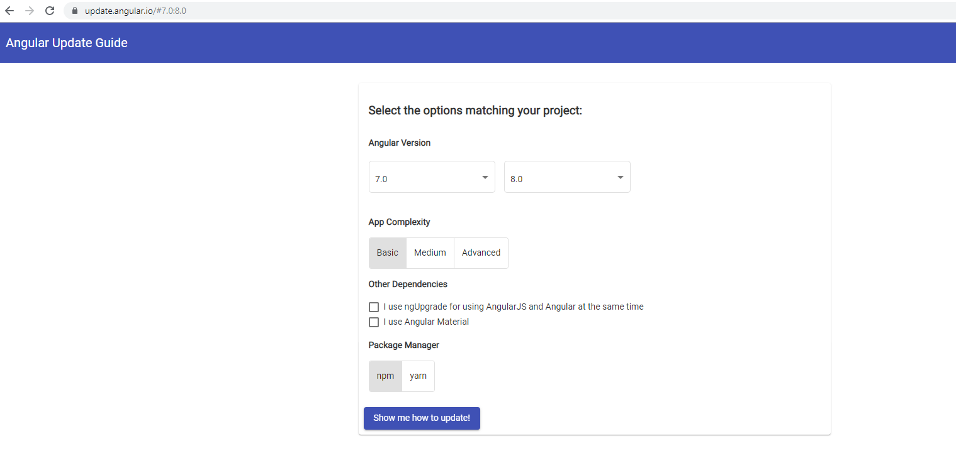

**Let’s say we want to move our Angular 7.0.0 project to Angular 8.0.0**

We get a complete overview of all the steps we need to take to update our application.

1. Before Update
2. During update
3. After Update

